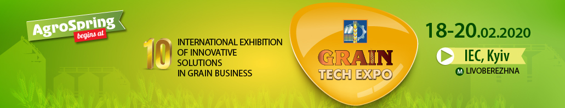

APPLICATION FORM № __
for participation in the exhibition
We kindly ask you to register us as a participant of the exhibition.
Full company name
Name for a signboard
Form of ownership
Type of activity

CEO |  |  | Phone
Person in charge |  |  | Phone
(of participation in the exhibition and compliance with safety regulations at the stand) | E-mail |  | Fax
 | Website

Country |  | Zip code
Region |  | Full address
City

Cost of participation in the exhibition
Exhibition area |  | m2 | Type площі
Number of open sides |  | from 1 to 4 | (equipped/unequipped/outdoor area/correspondence participation)
Price of exhibtion area |  | EUR
Participation fee |  | EUR | Ordered additional equipment
Additional equipment and services |  | EUR
Total cost of participation in the exhibition |  | EUR

Note: the General construction manager of the exposition at the exhibition is the Architect Bureau of Kyiv International Contract Fair, Ltd.
All the questions regarding stand construction must be agreed with the Architect Bureau before January 17, 2020 by phone +380 44 461 93 47.
After January 17, 2020 the price of additional equipment will be doubled.
This Application form is an integral part of the Contract and is made in two copies of equal legal force and can be signed as a fax copy with further obligatory submission of originals. One filled in copy of the Application form shall be sent to the Organizer.
Receipt of this Application Form by the Organizer from the Participant means that the Participant agrees completely with all conditions of participation in the exhibition, total participation cost and terms of payment.
By filling in this Application form, the Participant gives the permission to process his/ her personal data in order to include the data in the Organizer's database "Counterparties", e.g. name, whereabouts/place of residence, registration data, information on the taxation system, bank details, electronic identification data (IP-address, telephone, e-mail), surname, first name, patronymic name, personal signature and other data allowing to identify a person acting for and / or on behalf of the Participant in order to ensure implementation of tax relations, business relations, relations in the field of accounting and auditing, studying of consumer demand and statistics for marketing, information, advertising, commercial or other similar purposes. The Participant confirms that he or she is informed of his/her rights in accordance with the Law of Ukraine "On Protection of Personal Data" and the General Regulation on the Protection of EU Data 2016/679 (EU General Data Protection Regulation).

ORGANIZER |  |  | PARTICIPANT
Kyiv International Contract Fair, Ltd.
Address: 4 Akademika Bohomoltsia Str., Office 9, 01024, Kyiv |  |  | Address:
For correspondence: P.O. box В-13, 01001, Kyiv
Identification code: 21645267 |  |  | Identification code: __
Currency account: 26004305037 in  Branch-main administration JSC “Oschadbank" in Kyiv  and Kyiv region, МFО 322669 |  |  | Currency account:
TIN: 216452626653 |  |  | TIN:
Taxpayer certificate number: 200042337 |  |  | Taxpayer certificate number___
Tel./fax: +38 044 494 42 54 |  |  | Tel./Fax:__
E-mail: agro@kmkya.kiev.ua www.agrocomplex.kiev.ua |  |  | E-mail:
Deputy General Director – Financial director
 | Hanna Korol
Signature and seal |  |  | Signature and seal

Інформація для офіційного каталогу «Зернові технології 2020»

Text information for official catalogue Grain Tech Expo 2020

ДАНІ ПРО КОМПАНІЮ УКРАЇНСЬКОЮ МОВОЮ / COMPANY DETAILS IN UKRAINIAN
Назва компанії для алфавітного покажчика
Країна
Індекс
Місто
Вул./просп.
Контактні телефони
E-mail
Сайт
ДАНІ ПРО КОМПАНІЮ АНГЛІЙСЬКОЮ МОВОЮ / COMPANY DETAILS IN ENGLISH
Name of company for alphabetic list
Country
Zip Code
City
Str./ave
Contact phone numbers
E-mail
Web

ІНФОРМАЦІЙНО-РЕКЛАМНИЙ ТЕКСТ (ДО 50 СЛІВ)

INFORMATION ABOUT THE EXHIBITING COMPANY (TO 50 WORDS)
українською мовою / in Ukrainian | англійською мовою / in English

Please, send the filled in form with catalogue information in Word format.

